#### UNIVERSITY OF BUEA

**\*\*\*\*\*\*\*\*\*\*\*\*\*\***

#### FACULTY OF ENGINEERING AND TECHNOLOGY

**\*\*\*\*\*\*\*\*\***

#### DEPARTMENT OF COMPUTER ENGINEERING

**\*\*\*\*\*\***

#### 2022/2023 ACADEMIC YEAR

PROJECT REPORT TITTLED;



Mobile Application Development

Hybrid, Native, and Web Application development

**GROUP MEMBERS SUPERVISOR;**

**Dr. Valery Nkemini**

|  |  |
| --- | --- |
| **NAMES** | **MATRICULES** |
| **ENEMBE VERINE** | **FE20A033** |
| **AYAMBA OJONG NKONGHO** | **FE20A019** |
| **TONY KENYUI NANGAH** | **FE20A120** |
| **NKONGHO AYUK SHARIMA** | **FE20A090** |
| **GABILA YASMIN NAHKUNA** | **FE20A043** |

#### FRIDAY, MARCH 31st 2

**Mobile application programming**

**FoodAuc Mobile APP**

**Introduction**

Database design is a collection of steps that help create, implement, and maintain a business's data management systems. The primary purpose of designing a database is to produce physical and logical models of designs for the proposed database system.

In order to design a database for our food waste management system (FoodAuc) some relevant information based under different categories of Database concepts.

1. **Entity Relationship Diagrams(ER Diagrams)**

Entity relationship diagrams provide a visual starting point for database design that can also be used to help determine information system requirements throughout an organization. An entity-relationship diagram, or ER diagram, is essential for modeling the data stored in a database. Below illustrates the ER diagram of our system

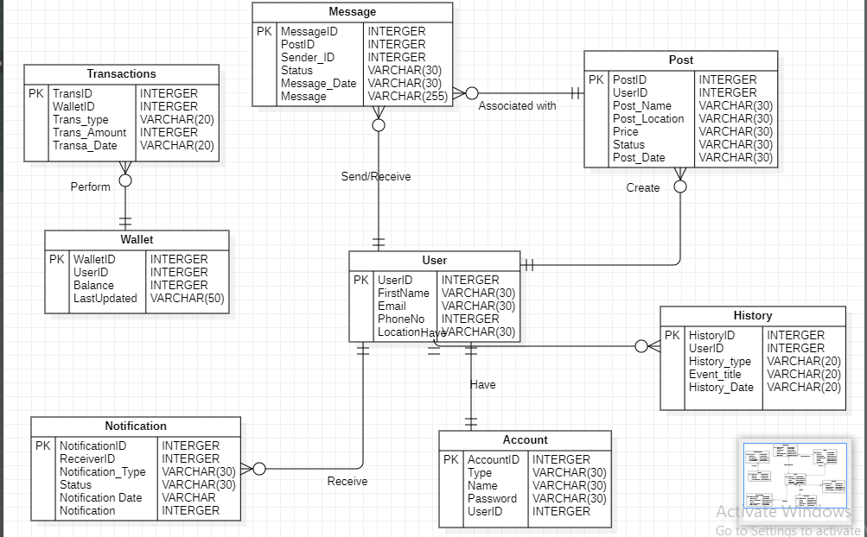

1. **Relational schema**

A relational schema is a set of relational tables and associated items that are related to one another. There are 2 levels of the Relational schema

**- The logical (or conceptual) level**

How users interpret the relation schemas and the meaning of their attributes.

1. **Physical Schema**

Physical schema is a term used in data management to describe how data is to be represented and stored (files, indices, et al.) in secondary storage using a particular database management system (DBMS).

Below shoes the physical schema been used for the FoodAuc application.

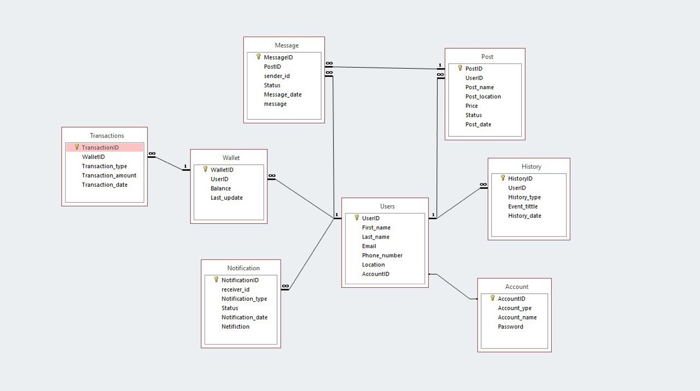

1. **Description**
2. Account Table

It is the first table of our system.

This table holds information about the user login credentials tis table is queried each the user request access to the system, it generates the first id of the user known as the account id. This table gives access only to the registration, login, forgot password page and user table.

1. User Table

This is the second table of our system it holds personal information about our user. this table is takes user account id as a foreign key and generate it own primary key.

This table give access to the registration, user profile, update profile page, post table, history table, Notification, Message table and Wallet table.

1. Post table

This table holds information about a food post table is also frequently accessed since information about post is frequently been updated. This post stores each post under a unique id.

The Create post, Update post, My post, message pages, user table, and message table have access to this table

1. Message Table

This table holds chat for particular food post which donor message collectors, it assigns each post message a particular message id.

Each message most identify to a post, a sender and receiver

The message page, notification page, user table post table have access to this table.

1. Wallet Table

The wallet table holds information about the finance, it holds the wallet id required to make transaction on the system either paying for food deposit withdraw.

The transfer, deposit, withdraw pages, transaction table, user table have access to this table.

1. History Table

The history table hold pass transaction of the of the user for example last post or last wallet transaction

The history page and user table have access to this page. Each history event is identified by a unique history id.

1. Transaction Table

Our system has a lot of transactions going on in it we keep tack of all user transactions from all users. Each transaction is identified by a unique transaction id.

Only the wallet table and transaction management page of the administrator.

1. Notification Table

Handling notification form food post generated by the system sent to different users

1. Implementation

The implementation of our data base

